**Tank reference**

http://mecha-zone.deviantart.com/art/Mecha-Zone-Crab-Tank-149207591

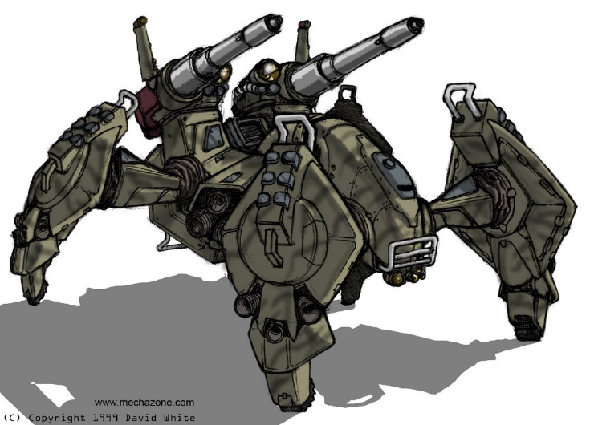

http://mecha-zone.deviantart.com/art/Spider-Tank-68905283

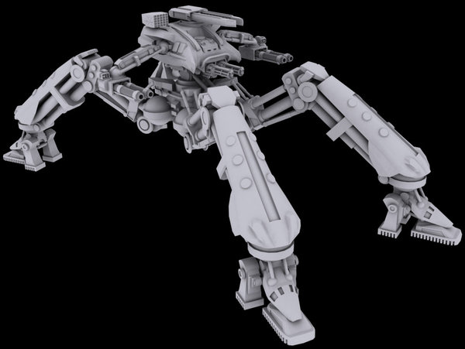

http://lh4.ggpht.com/_MoBU24dYClU/TNngZ57HxJI/AAAAAAAABKM/aHRTWqp4LFU/tank_3_wip_thumb%5B3%5D.jpg

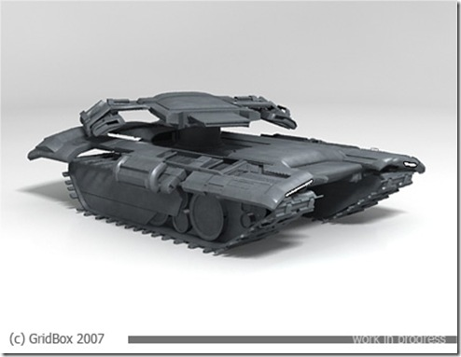

http://th05.deviantart.net/fs71/PRE/i/2013/036/b/b/mech_concepts_by_denmanrooke-d5tyh6h.jpg

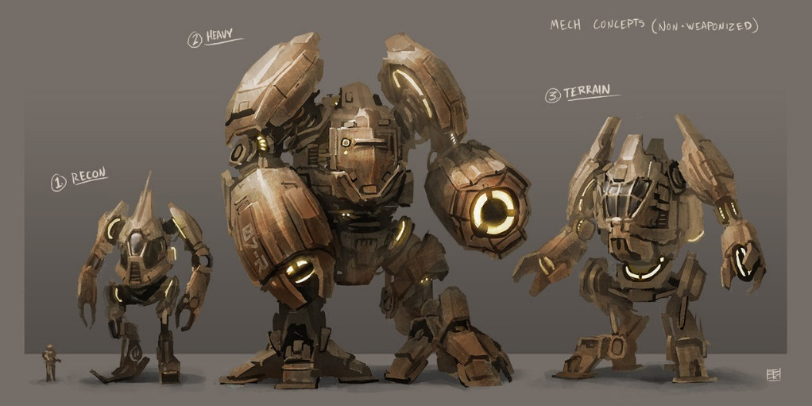

http://fc06.deviantart.net/fs70/i/2012/348/0/9/mech_500_by_fightpunch-d5nzxmw.jpg

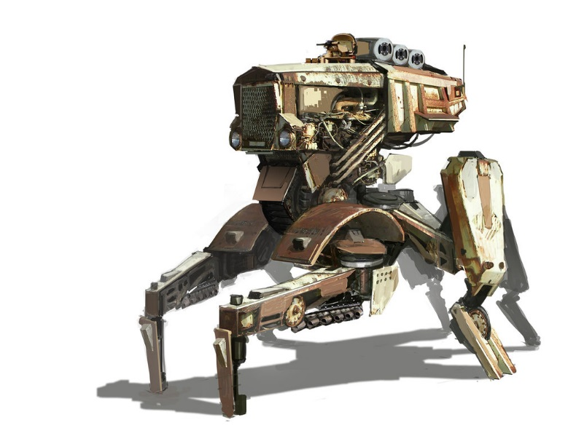

**Environment reference**

Starcraft II/I

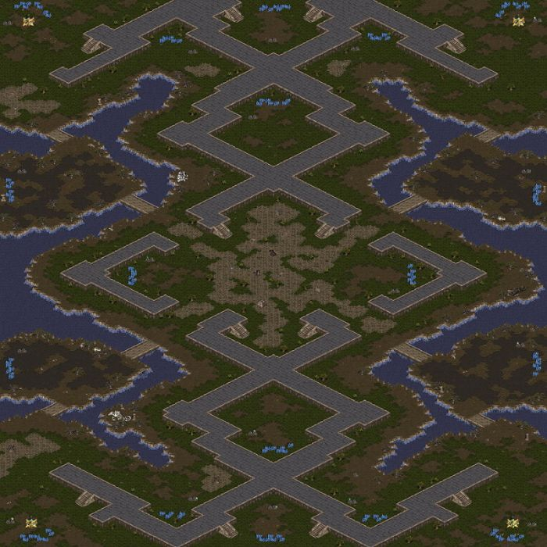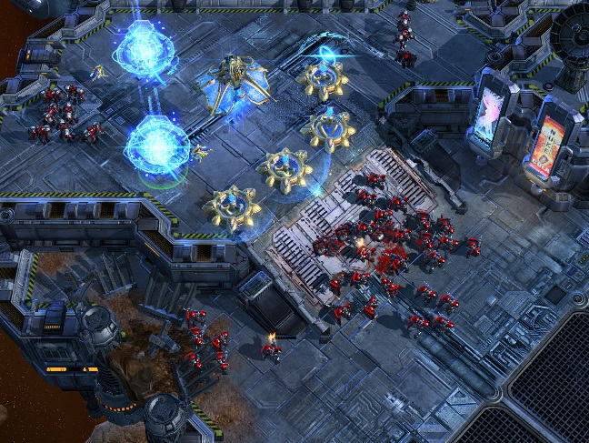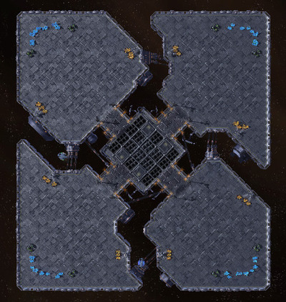

Tron (original)

